How was I born ?

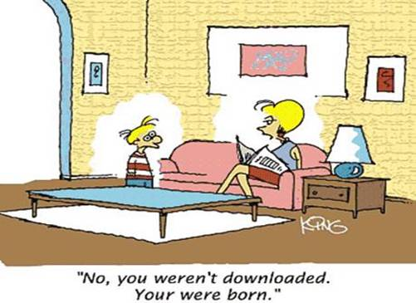
That’s not what Daddy told me!
A little boy goes to his father and asks 'Daddy, how was I born?'
The father answers, 'Well, son, I guess one day you will need to find out anyway! Your Mom and I first got together in a chat room on Yahoo. Then I set up a date via e-mail with your Mom and we met at a cyber-cafe. We sneaked into a secluded room, and googled each other. There your mother agreed to a download from my hard drive. As soon as I was ready to upload, we discovered that neither one of us had used a firewall, and since it was too late to hit the delete button, nine months later a little Pop-Up appeared that said:

(Scroll down...You'll love this ....)

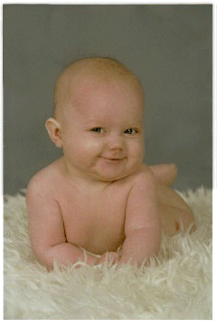
You got Male

=

 | Virus-free. www.avg.com

